**Final Project- Python for Data Analytics Spring 2022**.

**Submitted By: Jamil Ud Din**

**Dated: 05/25/2022**

**World Happiness Report 2015 to 2022**

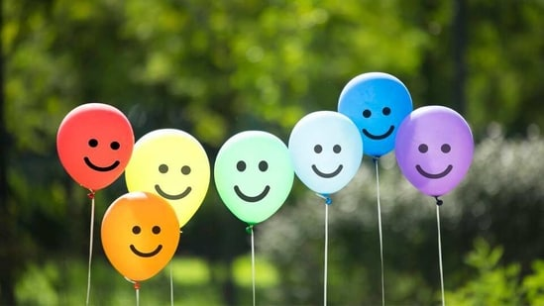

The world happiness report is a survey of 157 countries of the world that rank them how happy their citizens perceive themselves to be. The World Happiness Report is a publication of the United Nations Sustainable Development Solutions Network articles, it contains articles and rankings of  national happiness based on respondent ratings of their own lives, which the report also correlates with various quality of life factors. Wikipidia. <https://en.wikipedia.org/wiki/World_Happiness_Report>. The area of this survey focused on contributing factors to happiness are Economy (GDP per Capita , Family ( Social Support), Health(Life Expectancy), Freedom, Generosity, Trust (Government Corruption). The survey focuses on whether these factors have any direct relations with happiness score and happiness rank.

For my analysis I downloaded the dataset CSV file from Kaggle website [World Happiness Report 2015 to 2022 | Kaggle](https://www.kaggle.com/datasets/mayzannilarthein44/world-happiness-report-2015-to-2022). This dataset contains data from 2015 to 2022 world happiness survey data. The dataset contains 1229 rows and 12 columns. Data linked to google colab and were cleaned by looking any null values. There are some columns which are in numeric form but it include the Commas instead of dots. so as we have to use these values as an integer. So Firstly we will replace the ","(Commas) with "."(Dots) And then convert each of the column to numeric form. we don't need these columns as a String Type. That's why we will convert it to Numeric form. Data was checked for any possible outliers and found out that there were detected in Family (Social Support), Trust (Government Corruption), Generosity Columns. The threshold were set for each columns accordingly.

The Outcome of important parameters are summarized here:

* Happiness Score and Economy (GDP per Capita): the results shows that there is there is correlation between GDP per capita and Happiness score which is clearly visible and strong. The countries or regions having strong GDP or wealthier nations the happiness score is high compared to low GDP regions.
* Happiness Score and Family (Social Support); there is correlations between Happiness Score and Family (Social Support), the graph shows that higher social supports contributes to higher happiness score and vice versa.
* Happiness Score and Freedom: Strong correlation between these two parameters. People in those countries having more freedom are more happier than the people living where there are restrictions or oppression.
* Happiness Score and Health(Life Expectancy): The countries having higher Happiness score have significantly higher Health (Life Expectancy).
* Happiness Score and Generosity: it is found that there is no significant correlation between these two parameters.

**Some other important parameters are also analyzed and the interesting outcomes are as follows.**

* Economy (GDP per Capita) and Health (Life Expectancy): There is significant correlation between GDP per capita and Health/Life expectancy. The region having higher GDP the health (life expectancy) rate is high and has strong relationship between these two parameters.
* Economy (GDP per Capita) and Trust/Government Corruption: there is muted correlation between GDP per capita and Trust/Government Corruption. For most part, wealthier countries trust their government more than non-wealthy countries.
* **Economy ( GDP per Capita) and Freedom**: There is no significant correlation between GDP and Freedom.
* **GDP per capital and generosity: No correlation found between economy and generosity.**

**Mean/ Median results:**

The mean data (graph) shows Australia and New Zealand region has higher happiness ratio followed by Western Europe and North America. Th Southern African, Sub-Saharan Africa and Southern Asian regions have lowest happiness score and rank. The rank graph also shows similar results which is correlated to Happiness Score. The mean graphs show similar results for all the parameters. The mean table shows the average This Shows the Average Value of all the Feature Columns during all the years and This shows the Average Value of all the Feature Columns according to the Happiness Rank.

Other analysis reports: other analysis reports also have similar results and the links are listed in reference section.

References: Reference used for the word document and data analysis

<https://en.wikipedia.org/wiki/World_Happiness_Report>.

[LinearRegression | Kaggle](https://www.kaggle.com/code/pologonz/linearregression)

<https://www.hindustantimes.com/brand-stories/finally-happiness-is-unlocked-101613651577447.html>

<https://worldhappiness.report/>

# World Happiness Report 2021 Data Analysis Using Python | Data Analysis Project | Simplilearn

# <https://www.youtube.com/watch?v=HNtEq-dK3C4>

<https://stackoverflow.com/>

<https://pandas.pydata.org/docs/reference/api/pandas.DataFrame.html> <https://matplotlib.org/stable/plot_types/index.html>

<https://www.w3schools.com/python/default.asp>